Datafile 4. Immigration and Emigration 2014-2017

**1. Immigration over 2014-2017 Total for each year**

Visual : 36 Time Series with Peaks

---------------------------------------------------------------------------------------------------------------------

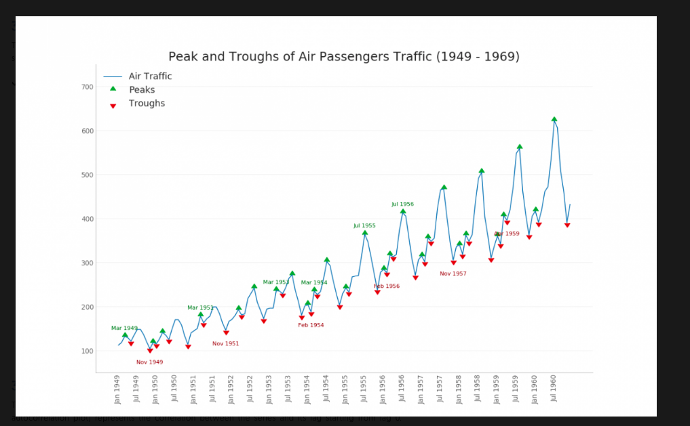

**2. Immigration Data by gender Men and Women**

Visual 1 : 32 Pie chart - with percentage for the total per year (orange-women and blue-men colors), separate the men slice

Visual 2 : 22 Density Plot - data by two genders over the years to find spikes

Or : 44 Area Chart Unstack to show the fluctuation over the years

---------------------------------------------------------------------------------------------------------------------

32 Pie Chart

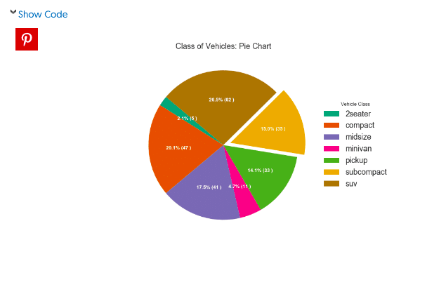

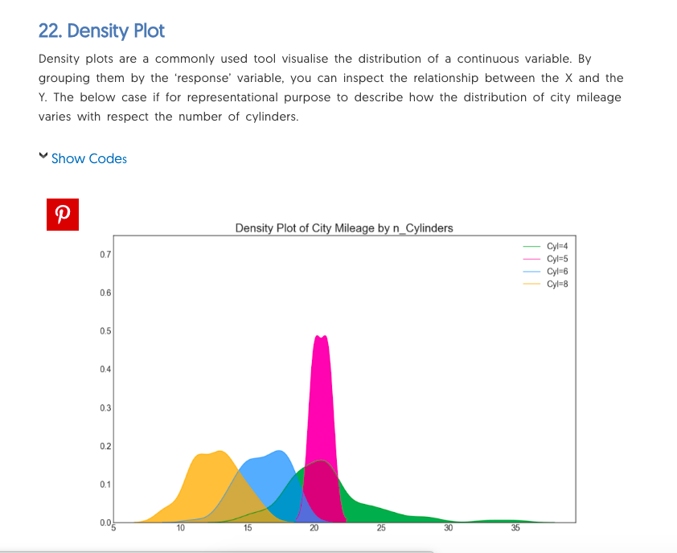

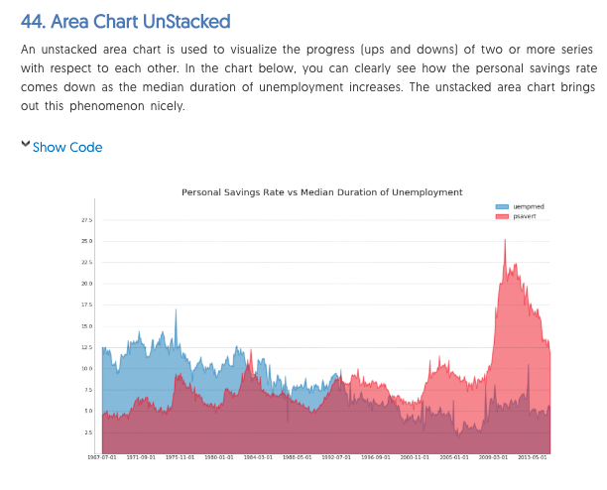

---------------------------------------------------------------------------------------------------------------------

**3. Emigration and Immigration**

Visual : 18 Slope Chart to highlight the difference between the two(spike highlight with red)

18 Slope Chart

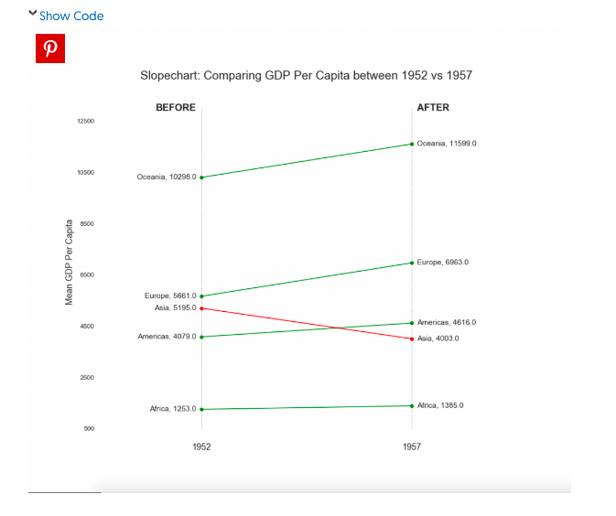

---------------------------------------------------------------------------------------------------------------------

**4. Emigration and Immigration by gender total**

Variables:

Emigration - men , women

Immigration - men, women

Visual 1: 29 Population Pyramid by age and gender.

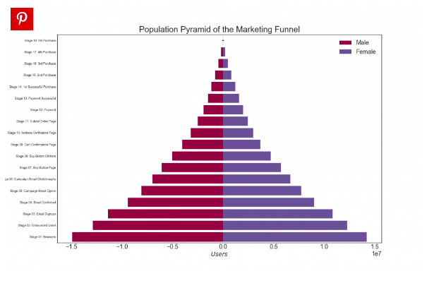

Here is another version of Pyramid found on the web. This one is better visualized

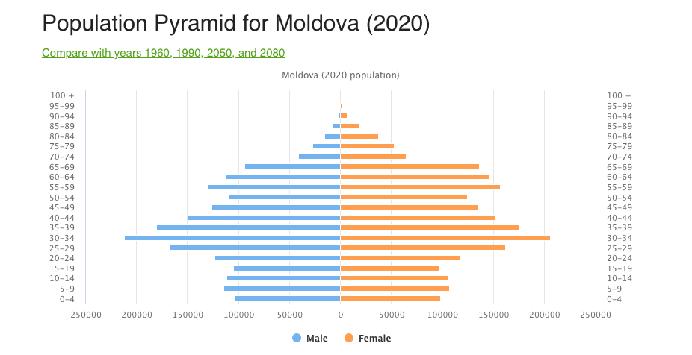

**5. Immigration Growth Rate**

Visual : Any line chart/ time series would do. Or we can just used the numbers like here

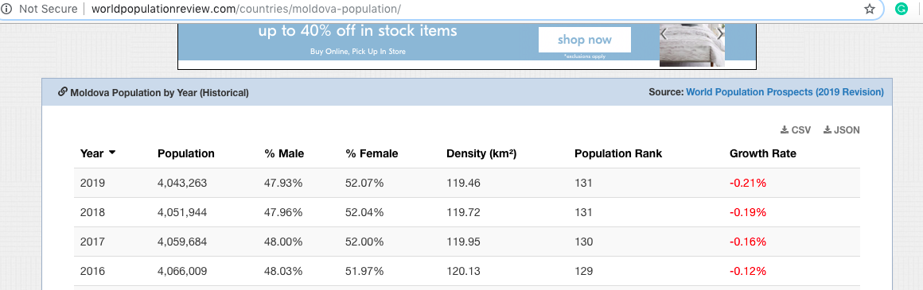

**6. Excel Calculations.**

By looking at the Emigration vs Immigration, I thought that we can do something with these numbers.

File Location: <https://github.com/suveico/Immigration_post_1991_latest/tree/master/data/real>

File Name

4.1 Excel_Calc Emigranti si imigranti in baza traversarilor frontierei de stat pe sexe si grupe de virsta_2014-2017

Sheet 1

Not all data might be relevant or will be used in the presentation.

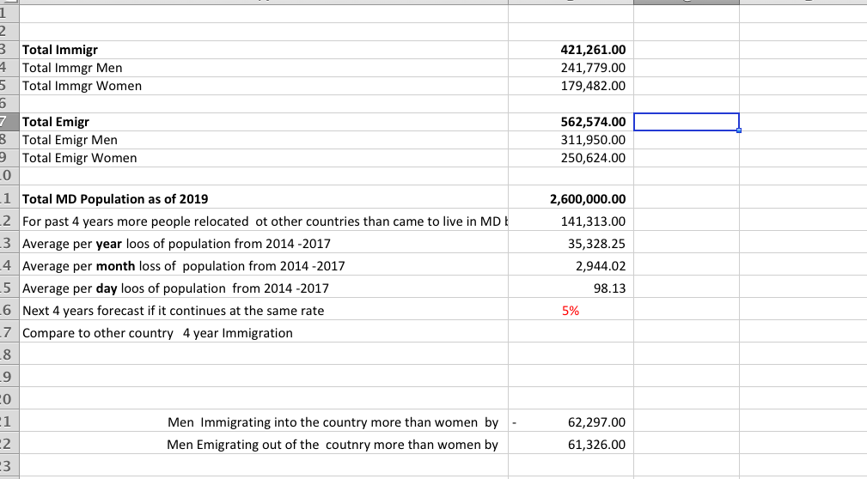

Other good visuals that can be considered

Categorical Plot 30

Bar Chart 34